Statistics Lecture 4.3: The Addition Rule for Probability

Compound Event: An event which joins two or more simple events

Example: Probability of rolling a 1 or a 5 to make the event 7 or 11 with dice playing craps if the first die lands on a 6.

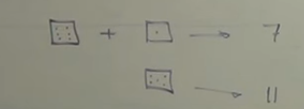

Or means one or the other or both to make event to happen.

P(A or B)=probability of “A” occurring or “B” occurring or both “A” and “B” in a single trial. (mutually exclusive )

P(Blond or Female) --- Not mutually exclusive

Example
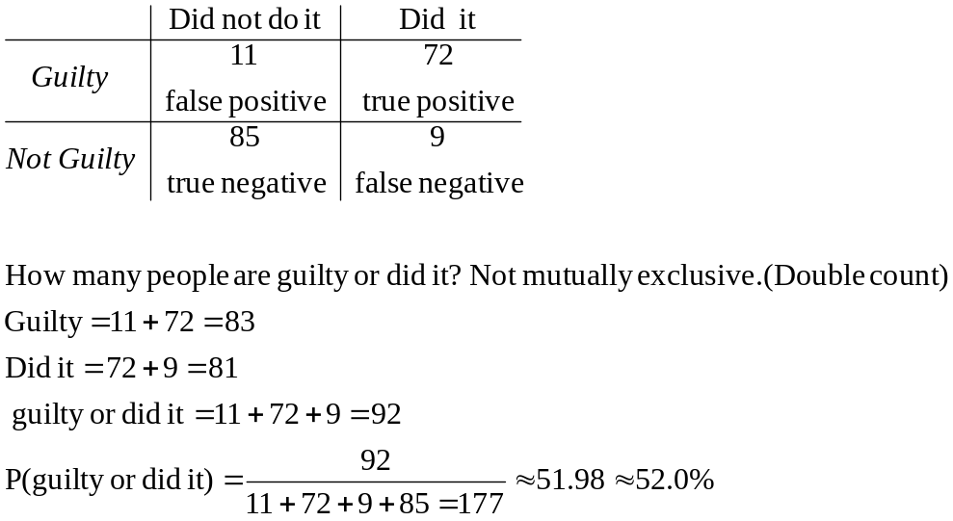

Addition rule: to remove double counts.
P(A or B)= requires the elimination of any double count.

Disjoint: Events (mutually exclusive events -- cannot happen at the same time)

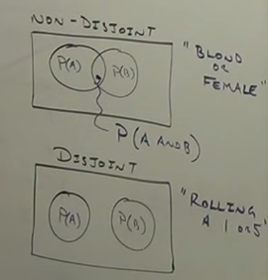

Example:
Probability of selecting a heart or a spade from a standard deck or cards.
P(♥ or ♠)=P(♥)+P(♠)-P(♥ and ♠)=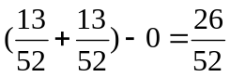=.5=50%

Example:
Probability of selecting a blond or a female.
Blond=.18
Female=.6
Blond female=.12
P(blond or female)=P(blond)+ P(Female)- P(blond and Female)
P(blond or female)=

Example:
Probability of selecting a Diamond or a King from a standard deck or cards.
P(♦ or K)=P((♦)+P(K))-P((♦ and K)
P(♦ or K)=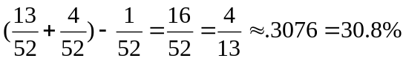

Complementary Events:
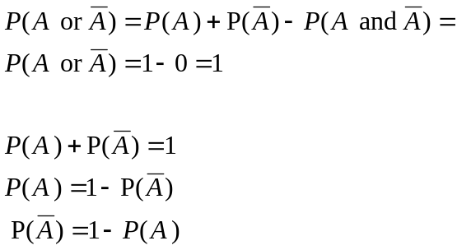

Example
